1.
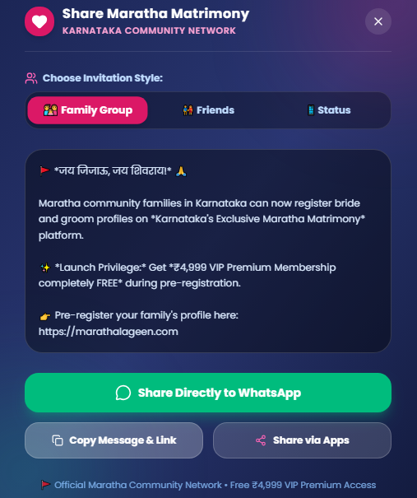
To be discussed : Do we need three options here

2. Open the landing page -> click on about us / success stories / contact tab -> and again click on home
The landing page is gone . main web page is displayed.

3.

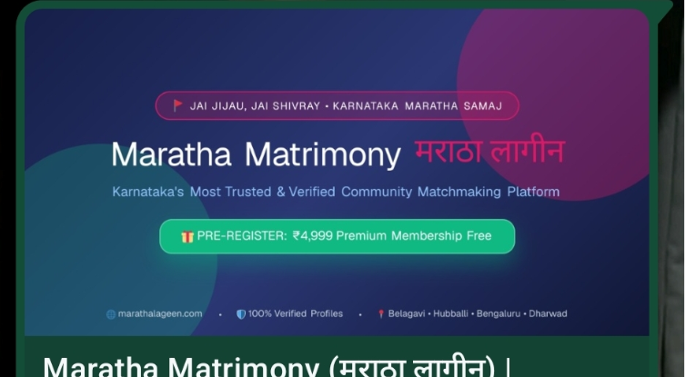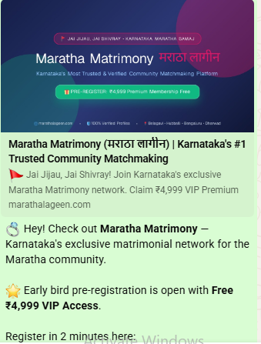
This is the image in the sharing apps . Can we change this to just to our logo ? Maratha lageen .

Like the below reference
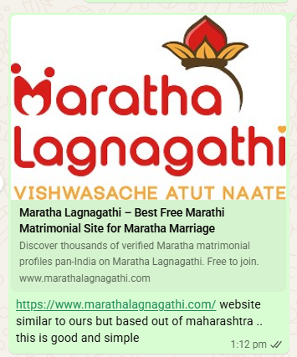

4.
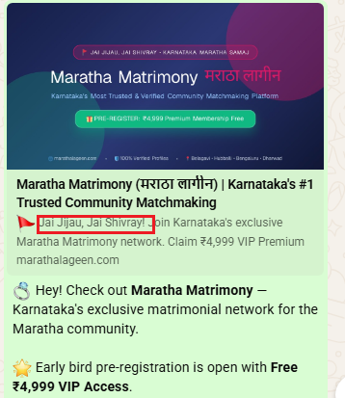

Instead of Jai Jijau and Jai Shivaray . Remove in Hindi
Write Jai Bhavani Jai Shivaji in kannada .
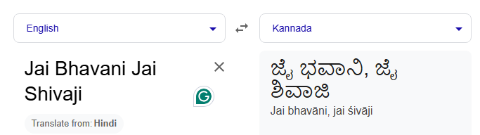

5. Video Placement
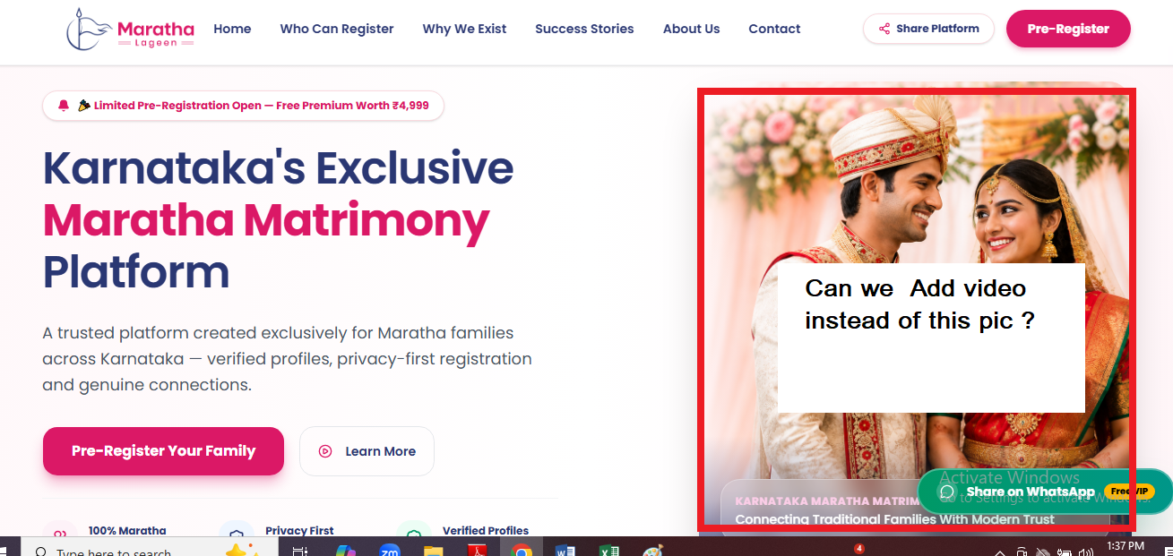

Can this be a vertical format video ?? or below this section in horizontal ?
Which suits better ?
Two options : add Maratha wedding pic here and video below or vice versa .
What you suggest ?

6. registering as Parents missing
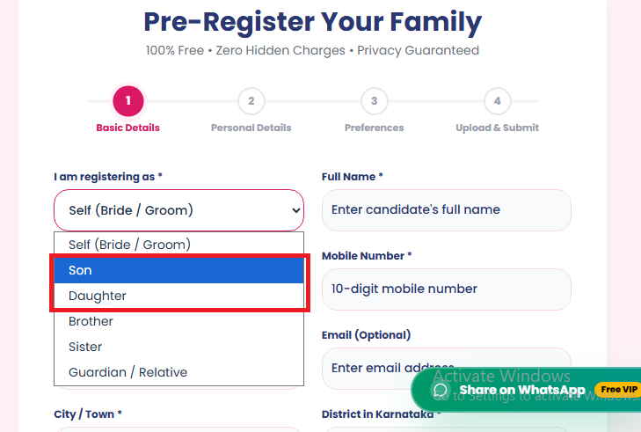

Remove Son/ Daughter and add Parents option

7. All the districts to be pre filled 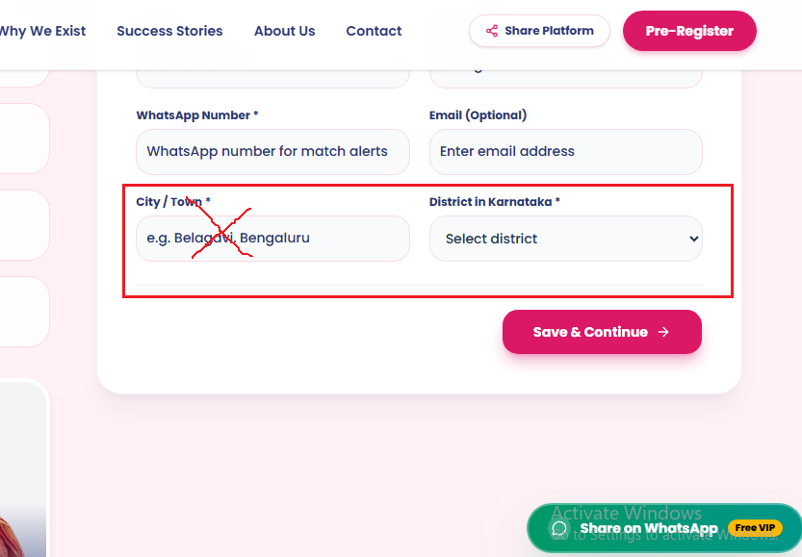

Let all the districts be prefilled , there are 31 districts in karnataka
We can have the taluk mentioned in the main page that we admin we fill , if not users end up typing different spelling for same taluk eg : Hoskote , Hosekote , Hosakote .

8. Pre registration form
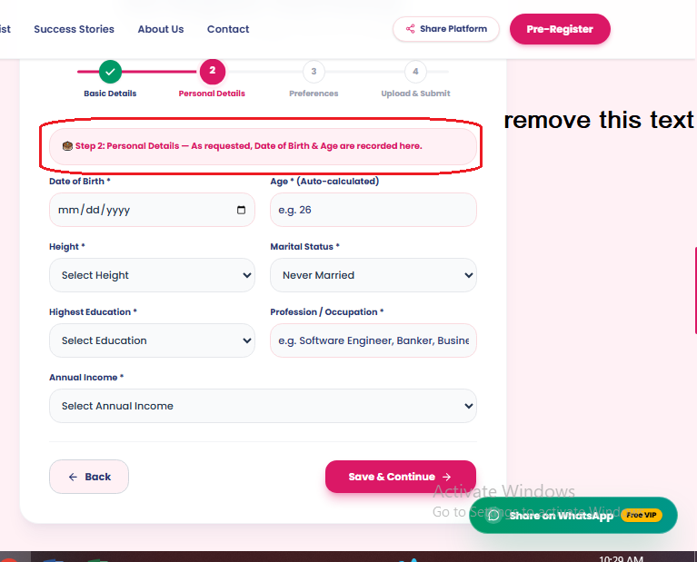

9. Pre registration form -> Field Addition
Time of Birth*

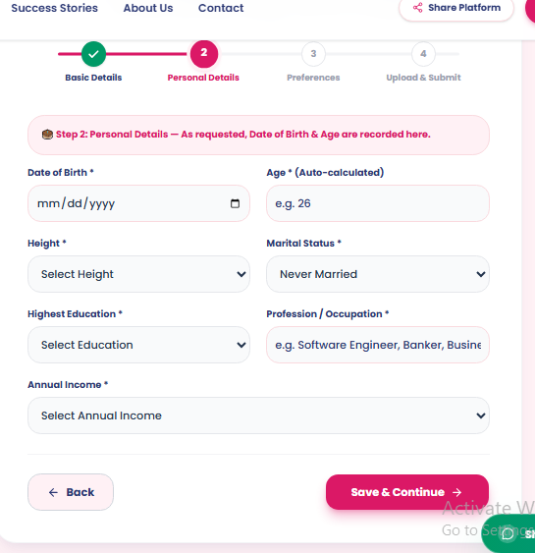

10. Adding lesser height option : Less than 4.5 feet and then range starting from there and height abve 6 feet
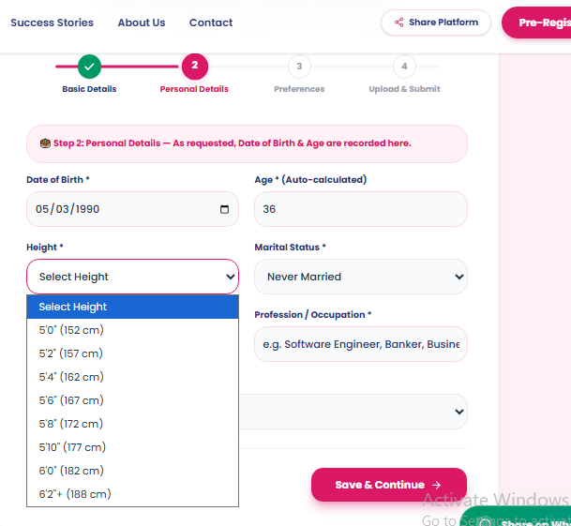

11 . Adding 2 Options : SSLC / PUC , Others
. 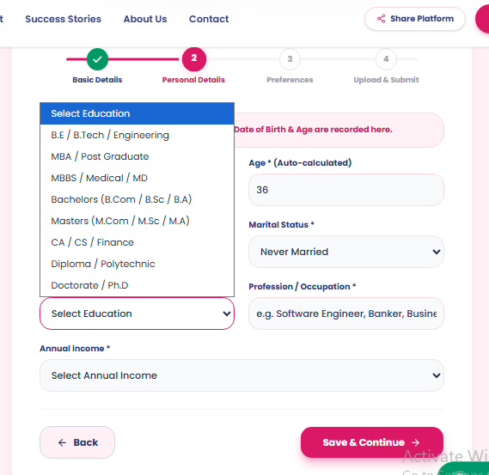

12. Income slabs to be optimized
Less than 3
3 to 5
5 to 7
8 to 10
11 to 15
16 to 20
21 to 25
Above 25

